


Multi-Functional Cane

ELBC803- Embedded Design Project
By

Ali Yazbeck – 94764
Serena Haidar – 90457
Zein Attar - 94266

Submitted to the Faculty of Engineering of the
Islamic University in Lebanon
Baalbeck, Lebanon
in partial fulfillment of the requirements for the degree of

BACHELOR OF ENGINEERING IN COMPUTER AND COMMUNICATIONS
Spring 2024-2025

Approved by:
Dr. Mohammad Chreif

TABLE OF CONTENTS

CHAPTER 1 INTRODUCTION 1
CHAPTER 2 System Design and Implementation 3
2.1 Introduction 3
2.2 Required Components 3
2.3 Circuit Design 4
2.4 Implementation Steps 5
CHAPTER 3 Conclusion and Future Work 8
3.1 Conclusion 8
3.2 Future Work 8

LIST OF FIGURES

Figure ‎2-1 Complete circuit 5
Figure ‎2-2 Circuit 5
Figure ‎2-3 Led connections 6
Figure ‎2-4 Connecting Arduino to breadboard 6

INTRODUCTION

What Is Engineering?
Engineering is the disciplined art of applying scientific and mathematical principles to design, build, and optimize structures, systems, and processes for humanity’s benefit [1]. Fundamentally, engineering solves real-world problems, serving people and the planet alike, and propelling society forward [2].
The field branches into specialties such as biomedical, chemical, electrical, civil, materials, and mechanical engineering, each addressing unique challenges from health to infrastructure to energy. Beyond these fields, emerging and interdisciplinary domains, like environmental, aerospace, software, and mechatronics, illustrate engineering’s boundless reach across modern life [3].
Yet all engineers share a common framework: define requirements, model solutions, test prototypes, and refine designs until form and function unite seamlessly.

Project Idea and Objectives
Globally, over 2.2 billion people live with a near or distance vision impairment or blindness. Alarmingly, at least 1 billion of these cases are treatable or preventable, highlighting a profound need for assistive technologies [4]
Vision loss often leads to reduced independence, limited mobility, and an increased risk of accidents, especially when navigating new environments.
Today, existing mobility aids like traditional white canes, often rely on mechanical contact feedback. More advanced versions offer vibration alerts or audio cues, yet neglect hazards like water puddles, low-light visibility, or emergency signaling. These limitations leave visually impaired people vulnerable in critical situations.
To bridge this gap, our project presents a Multifunctional Smart Cane: an integrated assistive system designed to extend the capabilities of traditional canes using embedded technology.
Key features:
- Ultrasonic sensors to detect nearby solid obstacles
- A water sensor to identify slippery surfaces like puddles
- A GPS + GSM module to allow users to send location-tagged SOS messages in emergency cases
- An LDR-based lighting system that activates a bright LED in dark environments to increase user visibility
- A digital compass and sound module intended to provide directional orientation cues
- A rechargeable Li-ion battery system, ensuring portable, long-lasting operation.

Project Objectives:
- Detect obstacles and slippery surfaces: Using ultrasonic sensors for solid objects and a water sensor for puddles.
- Enable Emergency response: One-button system sends GPS coordinates via SMS using GSM module.
- Improve visibility in low-light: Automatic LED activation triggered by an LDR sensor to make the user visible to others.
- Assist with basic directional navigation: A digital compass paired with sound feedback to help orient the user.
- Ensure long-lasting operation: Powered by a rechargeable Li-ion battery for portability and efficiency.

By delivering these features, we address the fundamental challenges of safety, independence, and confidence for visually impaired users.

What Is the ESP32?
The ESP32 is a series of low-cost and low-power System on a Chip (SoC) microcontrollers developed by Espressif Systems. Designed for mobile devices, wearable electronics and Internet of Things (IoT) applications, the ESP32 integrates Wi-Fi and Bluetooth wireless capabilities and offers a dual-core processor.
Engineered using TSMC's 40nm low-power technology, the ESP32 achieves ultra-low power consumption with a combination of several types of proprietary software and hardware features. It offers the flexibility and performance for a wide range of applications. [5]

ESP32 Specifications:
- Processor : Dual-core or single-core Tensilica Xtensa LX6 microprocessor, operating at up to 240 MHz.
- Memory: 520 KiB SRAM and 448 KiB ROM, with support for external flash and PSRAM.
- Wireless Connectivity:
  - Wi-fi : 802.11 b/g/n
  - Bluetooth: v4.2 BR/EDR and BLE

- Peripheral interfaces:
  - 34 programmable General Purpose Input Output interfaces (GPIOs)
  - 12-bit SAR ADCs, DACs, SPI, UART, CAN, PWM and more

- Clocks and timers:
  - Internal 8 MHz oscillator with calibration.
  - Internal RC oscillator with calibration
  - External 2 MHz ~ 60 MHz crystal oscillator (40 MHz only for Wi-Fi/Bluetooth functionality)
  - External 32 kHz crystal oscillator for RTC with calibration

- Security features: flash encryption and cryptographic hardware acceleration (AES, RSA, ECC, RNG).

- Power Management: 5 power modes, including deep sleep(10 μA.) and Hibernation for energy efficient operation. [6]

System Design and Implementation

Introduction
In this chapter, you need to list the components you will use in your project and the steps you will follow to implement it with figures to illustrate your text.

Required Components
In this paragraph you need to list the components of your project. Only those that you used:

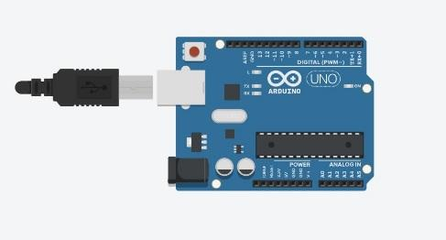 | ARDUINO UNO R3 x1  The main brain for the system.
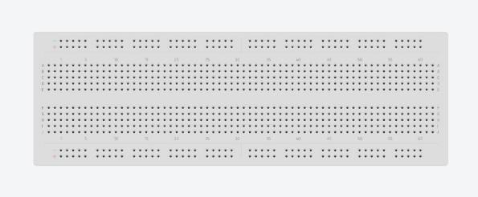 | Breadboard x1  For the connection and components
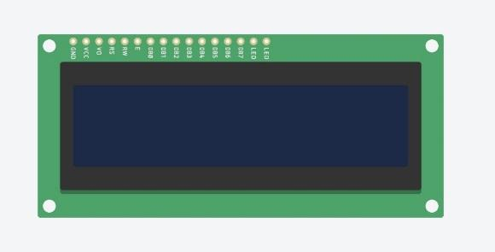 | 16*2 LCD x1  To display the temperature
 | RGB LED x7  To indicate the color corresponding to each temperature
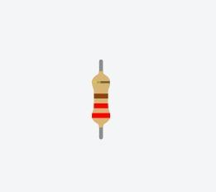 | Resistor 220-ohm x7  To implement electrical resistance as a circuit element
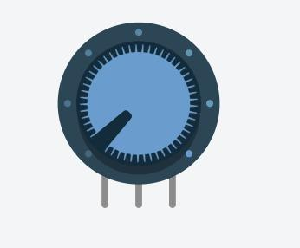 | Potentiometer x1  To measure electric potential
 | Temperature sensor x1  To measure the amount of heat energy or even coldness that is generated by an object or system
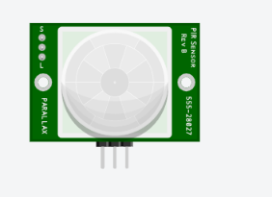 | PIR sensor X1

Circuit Design

In Figure ‎2-1, we show …
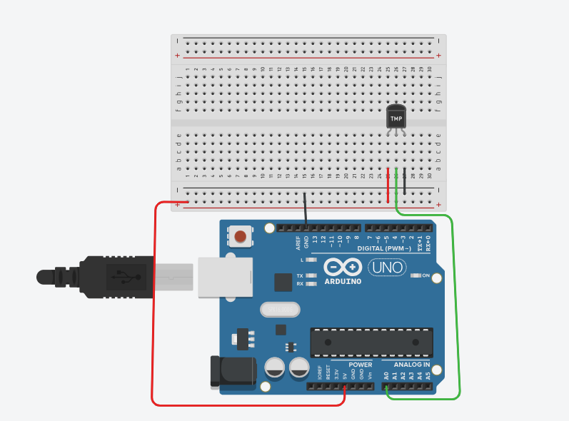
Figure ‎2-1 Circuit

Implementation Steps
Here, you need to explain how did you implemented your project with figures explaining the different steps.
- Step 1
We connect the led to the pin … as shown in
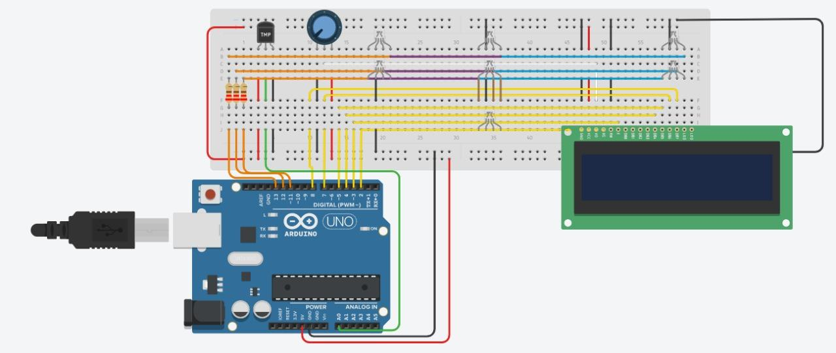
Figure ‎2-2 Led connections

An example of a figure is shown in Figure 2.2. Pay attention how this figure has a caption under it. This is done by right clicking on your figure and then choosing “insert a caption”.

The list of figures in page III is dynamic. You need to right click on it and update it when you finish inserting all your figures and captions so it is updated with the final figures in your report.
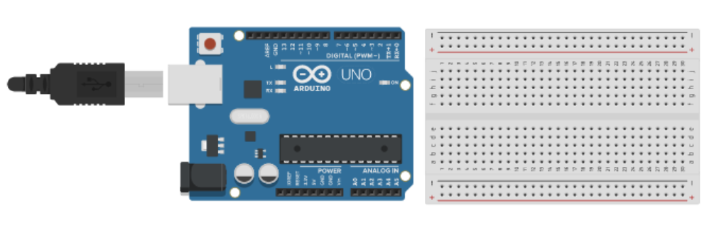
Figure ‎2-3 Connecting Arduino to breadboard

Conclusion and Future Work

Conclusion
In this paragraph, you write a summary of what you presented in the above two chapters. Instead of using expressions like “in our project we will implement ….”, in the conclusion we usually use expressions like “As we could see above, in our project we implemented ……”.
Besides, you need to write about the experiences you learned while taking the course and implementing the project.

Future Work
In this paragraph, you need to write any idea you have about expanding the work you did in your project to be more developed and to be used in real life.

References

[1] | R. J. Smith, "Britannica," 28 Apr 2025. [Online]. Available: https://www.britannica.com/technology/engineering. [Accessed 8 May 2025].
[2] | A. C. o. E. Companies, "ACEC," Yoko Co, 2025. [Online]. Available: https://www.acec.org/about-acec/what-is-engineering/. [Accessed 13 May 2025].
[3] | N. University, "National University," 2025. [Online]. Available: https://www.nu.edu/blog/types-of-engineering/#15-different-types-of-engineering-jobs. [Accessed 13 May 2025].
[4] | W. H. Organization, "World report on vision," World Health Organization, 2019.
[5] | Espressif, "Espressif," Espressif Systems, 2025. [Online]. Available: https://www.espressif.com/en/products/socs/esp32. [Accessed 13 May 2025].
[6] | Espressif, "Espressif," 2025. [Online]. Available: https://www.espressif.com/sites/default/files/documentation/esp32_datasheet_en.pdf. [Accessed 13 May 2025].

